Extra Practice 1
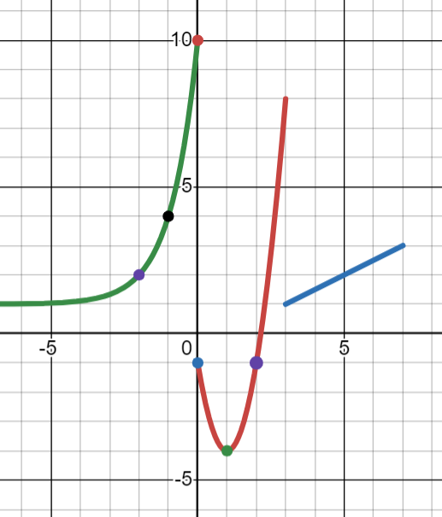
1). [P] Write the piecewise defined function for the graph pictured here.
Note that the exponential function is $3^{x}$ (do you see why?)

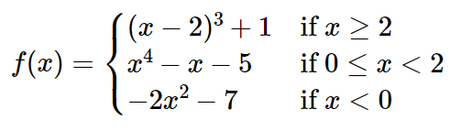
2). [P]

Evaluate: $f\left( f\left(1\right) \right)$

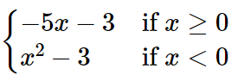
3). [P]
$g\left(x\right)=$ Evaluate: $g\left(1-g\left(-1\right)\right)$

4). [P]
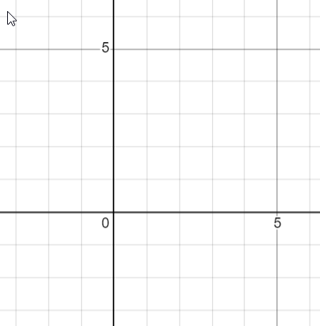
Sketch the parametric path defined by…
$x\left(t\right)=\left|t\right|+2$ and $y\left(t\right)=|t-1|$
… on the time interval $-2≤t≤2$
Include time and direction information on the path.

5). [P] Consider these two sets of parametric equations
$x\left(t\right)=t$ $y\left(t\right)=\frac{1}{t-1}$ vs. $x\left(t\right)=t^{2}$ $y\left(t\right)=\frac{1}{t^{2}-1}$

a). Are the paths defined by these pairs the same or different? How do you know?
a). For these two motions does the point start at the same place at t = 0?
b). For these two motions does the point move in the same direction as t increases?
c). What’s the difference between motions? How do you think about it?

6). [P] Find the cartesian equation corresponding to $x\left(t\right)=4^{t}+1$ and $y\left(t\right)=\frac{1}{4^{t}-1}$ .
Look at x(t) to determine how its domain is restricted.

7). [P] Find the cartesian equation corresponding to $x\left(t\right)=\sqrt{2t-1}$ and $y\left(t\right)=sin(2t)$
Look at x(t) to determine how its domain is restricted.

8). [P] Consider: $x\left(t\right)={\left(10-t\right)}^{2}+2$ and $y\left(t\right)=7-t$ .
At what time does the point cross the x-axis? What are the coordinates of the x-intercept of the path?

9). [P] Find x(t) and y(t) equations so a point will traverse the path $y=x^{2}+x+1$ reaching (2, 7) at t = 5 and (10, 111) at t = 7

10). [C] A student is trying to answer the following question:
Create a parameterization of $y=\frac{x}{1-x}-2^{\sin\left(x\right)} so as time increases the point moves right to left along the curve$

They say: “wait ... I can’t imagine what that path will look like ...” Explain to the student why they don’t need to be able to visualize the path to create a parameterization for it.

11). [C] You know $x\left(t\right)=cos(t)$ and $y\left(t\right)=sin(t)$ define a circular motion.
Give a clear reason how you know changing x(t) to be $x\left(t\right)=\cos\left(2^{t}\right)$ and $y(t)$ to $y\left(t\right)=\sin\left(2^{t}\right)$ won’t change the location of the circle’s center or size of the circle.
12). [P/C] A runner circles a racetrack. Their motion is given by $x\left(t\right)=30\cos\left(\frac{π}{90}t\right)$ and $y\left(t\right)=20\sin\left(\frac{π}{90}t\right)$ where t is in seconds.

a). How long does it take the runner to complete one lap?
b). Write the equation for the motion of a runner who starts exactly 10 seconds after the first, and who finishes 5 seconds earlier.
c). What are the (x, y) coordinates where the second runner passes the first? [ you can use a calculator for this one ]

Solutions to Extra Practice 1

1). [P] Write the piecewise defined function for the graph pictured here.
Note that the exponential function is $3^{x}$ (do you see why?)
Look at the growth triangles for the reference points on the exponential. Each time the growth in y multiplies by 3.
Here’s the piecewise defined function for this equation:
$$f\left(x\right)=\left\{\begin{aligned}\begin{matrix}3^{x+2}+1 & x≤0\end{matrix} \\ \begin{matrix}3{\left(x-1\right)}^{2}-4 & 0<x<3\end{matrix} \\ \begin{matrix}\frac{1}{2}\left(x-3\right)+1 & 3<x≤7\end{matrix}\end{aligned}\right.$$


2). [P]

Evaluate: $f\left( f\left(1\right) \right)=-57$


3). [P]
$g\left(x\right)=$ Evaluate: $g\left(1-g\left(-1\right)\right)$.

$g\left(-1\right)$ is -2. We need $g\left(1-\left(-2\right)\right)$, or $g(3)$. $g(3)$ is $-18$

4). [P]
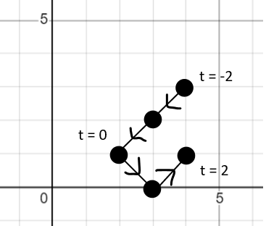
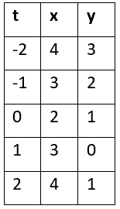
Sketch the parametric path defined by…
$x\left(t\right)=\left|t\right|+2$ and $y\left(t\right)=|t-1|$
… on the time interval $-2≤t≤2$
Include time and direction information on the path.
You don’t need to make a table, but it’s a nice way to keep things organized.

5). [P] Consider these two sets of parametric equations
$x\left(t\right)=t$ $y\left(t\right)=\frac{1}{t-1}$ vs. $x\left(t\right)=t^{2}$ $y\left(t\right)=\frac{1}{t^{2}-1}$

a). Are the paths defined by these pairs the same or different? How do you know?
They’re the same. In the first, I substitute x for t to get $y=\frac{1}{x - 1}$ as the path. In the second, I substitute $x$ for $t^{2}$ to get $y=\frac{1}{x -1}$ also.

a). For these two motions does the point start at the same place at t = 0?
Yes. X(0) = 0 for both.

b). For these two motions does the point move in the same direction as t increases?
Yes. As t increases, x increases for both.

c). What’s the difference between motions? How do you think about it?
Let’s compare the x-position over time...

t x(t)=t $x\left(t\right)=t^{2}$
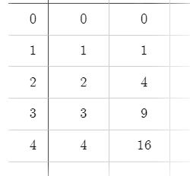
At each time, the second equation is a larger x coordinate. So we know it must be moving to the right faster. Not only that, but the speed is increasing. From t = 1 to 2, the x position increases by 3 (so 3 units per second), but from t = 2 to 3 it increases by 5 (So 5 units per second) and then by 7 units per second.

So, in a word, the point is accelerating to the right.

6). [P] Find the cartesian equation corresponding to $x\left(t\right)=4^{t}+1$ and $y\left(t\right)=\frac{1}{4^{t}-1}$ .
Look at x(t) to determine how its domain is restricted.

Isolating $4^{t}$ in the x equation: $x-1=4^{t}$
Now we can substitute that into the y-equation: $y\left(t\right)=\frac{1}{x-1-1}=\frac{1}{x-2}$ for $x>1$
(because the original x(t) is always > 1 ).

7). [P] Find the cartesian equation corresponding to $x\left(t\right)=\sqrt{2t-1}$ and $y\left(t\right)=sin(2t)$
Look at x(t) to determine how its domain is restricted.

Isolating t in the x equation: $x^{2}=2t-1$ $x^{2}+1=2t$ $t=\frac{x^{2}+1}{2}$
Substitute that into the y-equation: $y=\sin\left(2⋅\frac{x^{2}+1}{2}\right)=\sin\left(x^{2}+1\right)$ for $x≥0$

8). [P] Consider: $x\left(t\right)={\left(10-t\right)}^{2}+2$ and $y\left(t\right)=7-t$ .
At what time does the point cross the x-axis? What are the coordinates of the x-intercept of the path?

An x-intercept is when y is 0. So let’s solve: $0=7-t$ . Therefore at $t=7$ the path crosses the x-axis.
The x-coordinate at $t=7$ is $x\left(7\right)={\left(10-7\right)}^{2}+2=11$. So there’s an x-intercept at $(11,0)$.

I had you solve for the time first as a hint that you didn’t need to find the cartesian equation, though you could also have done that.

9). [P] Find x(t) and y(t) equations so a point will traverse the path $y=x^{2}+x+1$ reaching (2, 7) at t = 5 and (10, 111) at t = 7
$$x\left(t\right)=4\left(t-5\right)+2$$
$$y\left(t\right)={\left(4\left(t-5\right)+2\right)}^{2}+4\left(t-5\right)+3$$

10). [C] A student is trying to answer the following question:
Create a parameterization of $y=\frac{x}{1-x}-2^{\sin\left(x\right)} so as time increases the point moves right to left along the curve$

They say: “wait ... I can’t imagine what that path will look like ...” Explain to the student why they don’t need to be able to visualize the path to create a parameterization for it.

Even if you can’t imagine the curve, the cartesian equation $y=\frac{x}{1-x}-2^{\sin\left(x\right)}$ literally says the relationship between x and y. It tells you how you can find y if you know x. So you can start by describing an $x(t)$ equation for how you determine your x-coordinates at different times. One that works for this problem might be $x\left(t\right)=10-t$.

If you want it to follow that hard-to-imagine path, you know the y-coordinates still need that same relationship to the x coordinates. So if the x-coordinate is $10-t$. The y-coordinate can be found as: $\frac{10-t}{1-\left(10-t\right)}-2^{\sin\left(10-t\right)}$, and you know it will work, even if you can’t imagine it.

11). [C] You know $x\left(t\right)=cos(t)$ and $y\left(t\right)=sin(t)$ define a circular motion.
Give a clear reason how you know changing x(t) to be $x\left(t\right)=\cos\left(2^{t}\right)$ and $y(t)$ to $y\left(t\right)=\sin\left(2^{t}\right)$ won’t change the location of the circle’s center or size of the circle.
$\cos\left(2^{t}\right)$ still can only have outputs in the range -1 to 1. So the x-coordinates of the path are still between -1 and 1. Similarly for y(t). Therefore neither center nor size change.
In case you’re worried it won’t make a circle anymore, note that for a single t-value, the angle being used for sine and cosine will be the same, therefore it should still make a circle. Think of it this way: Let $A=2^{t}$ where A is the angle. Now we have: $x\left(t\right)=cos⁡(A)$ and $y\left(t\right)=sin⁡(A)$ for every time t.
12). [P/C] A runner circles a racetrack. Their motion is given by $x\left(t\right)=30\cos\left(\frac{π}{90}t\right)$ and $y\left(t\right)=20\sin\left(\frac{π}{90}t\right)$ where t is in seconds.

a). How long does it take the runner to complete one lap?

$\frac{π}{90}t$ gives the angle to the runner as the move around the ellipse. At $t=0$, the angle is 0. After a full lap, their angle will be $2π$. Let’s solve for t: $\frac{π}{90}t=2π$ $t=2π⋅\frac{90}{π}=180$. So 180 seconds.

b). Write the equation for the motion of a runner who starts exactly 10 seconds after the first, and who finishes 5 seconds earlier.

At $t=10$ I want the angle to be 0, and at $t=175$ I want the angle to be $2π$. Let’s make a linear function that connects the points $(10, 0)$ and $\left(175 , 2π\right)$. Sketch a graph if it helps you think about this.
$A\left(t\right)=\frac{2π}{165}(t-10)$ does it. So $x\left(t\right)=30\cos\left(\frac{2π}{165}(t-10)\right) and y\left(t\right)=20\sin\left(\frac{2π}{165}(t-10)\right)$

c). What are the (x, y) coordinates where the second runner passes the first?
First let’s find the time when they pass by setting the two angle equations equal and solving for time.

$\frac{2π}{165}\left(t-10\right)=\frac{π}{90}t$ $\frac{2π}{165}t-\frac{π}{90}t=\frac{20π}{165}$ $t\left(\frac{2}{165}-\frac{1}{90}\right)=\frac{20}{165}$
$t\left(\frac{12}{990}-\frac{11}{990}\right)=\frac{20}{165}$ $t\left(\frac{1}{990}\right)=\frac{20}{165}$ $t=\frac{20⋅990}{165}=120$

Plugging this time into the original equations $x\left(t\right)=30\cos\left(\frac{π}{90}t\right)$ and $y\left(t\right)=20\sin\left(\frac{π}{90}t\right)$ will give me the (x, y) coordinates:
$$x\left(120\right)=30⋅\cos\left(\frac{4π}{3}\right)=-15$$
$$y\left(120\right)=20⋅\sin\left(\frac{4π}{3}\right)=-20⋅\frac{\sqrt{3}}{2}=-10\sqrt{3}$$
So they meet at $(-15, -10\sqrt{3} )$

